

A Project Report On

**PONG GAME IN JAVA**

**Project**

**By**

**Name: Gokul S**

**Batch:** 2022-7671

**Center: Chennai-Chrompet**

Under the Guidance of,

**Chittaranjan Ghosh.**

**Technical Trainer**

**EduBridge**

(School of coding)

**Introduction:**

**T**his Pong Game Java Project game has been designed using Java Applet. It has single player as well as double player option. It provides users a new experience that is different from the usual pong games available. It is a freeware game so users need not pay any amount to play it.  As we all know, a pong game consists of two pads on both sides and a ball, and the player has to make sure that he hits the ball with the pad without missing it to win the game and more score.

**Objective:**

* To make 2D Arcade Game which has simple and interactive system.
* The game should be runnable on any PC.
* Minimum interaction with GUI should be required to play the game.
* The gameplay should be easy enough so that anybody can play the game on the go.

**Modules :**

* **Paddle Control**
* **Bouncing ball**
* **Score counting**

Paddle Control

* The players can control the paddle movement in the two separate ways because there are two players. It can be controlled by the keyboard.
* Up and Down arrow keys for Red player/Right Player
* W and S keys keys for Green player/Left Player

Bouncing Ball

* Software will be used to assigning new locations of the ball as the ball bounce around walls (edges of the screen) paddle. When the angle of incidence changes, the angle of reflection changes too.

Score Counting

* Players use the paddles to hit a ball back and forth. The goal is for each player to reach eleven points before the opponent points are earned when one fails to return the ball to the other. The score will be displayed on the up for right player and up left of the left player of the screen.

**Software Requirements:**

* **Operating system:** Windows 10.
* **Tools used :** Eclipse.
* **Language used :** JAVA.
* **Packages used :** JAVA SWING, JAVA AWT

**There are 6 very short and intuitive classes in this game:**

**Game.java** handles the rendering and physics updating using a separate thread. It contains all the objects. This class extends Canvas to draw and implements Runnable to run the game loop.

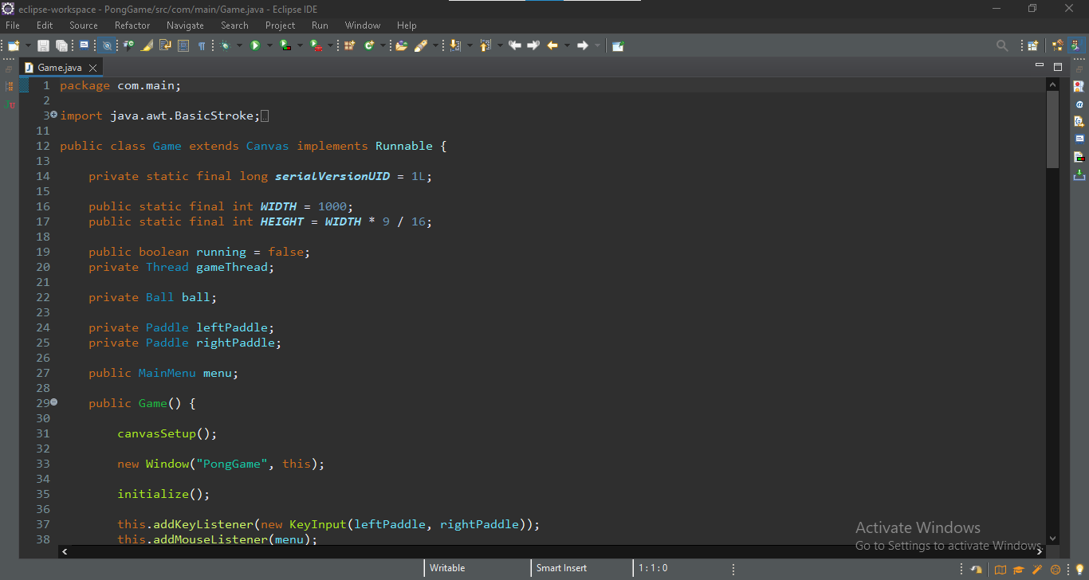

**Window.java** handles the JFrame and adds the Game Canvas into it.

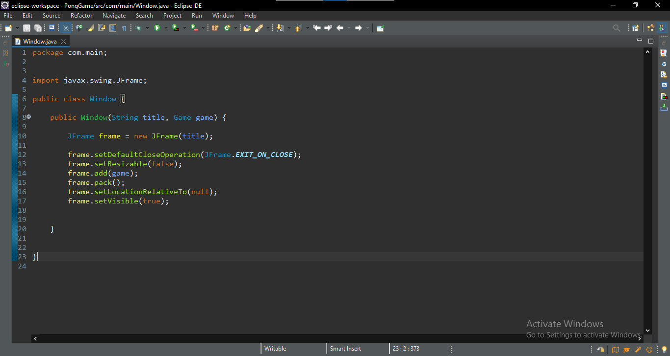

**Ball.java** contains the properties for the ball that bounces around.

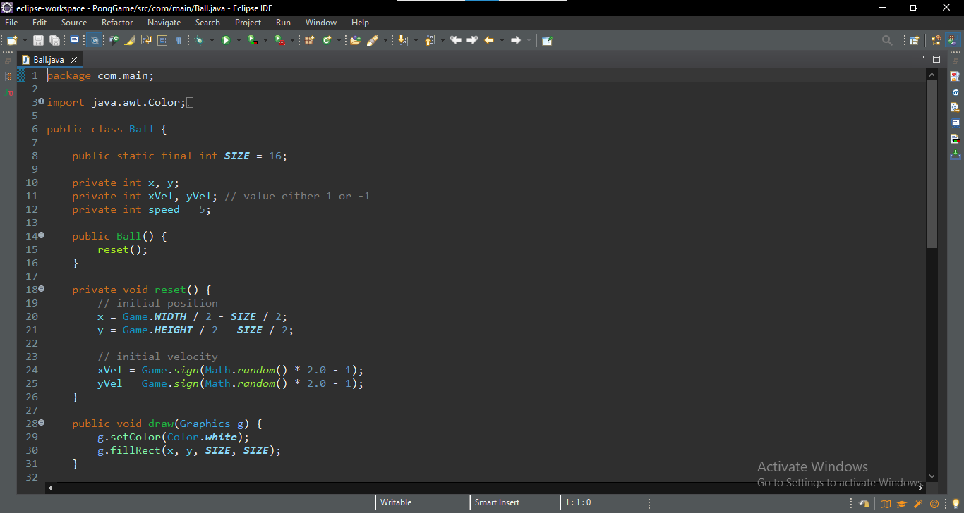

**Paddle.java** contains the properties for both paddles

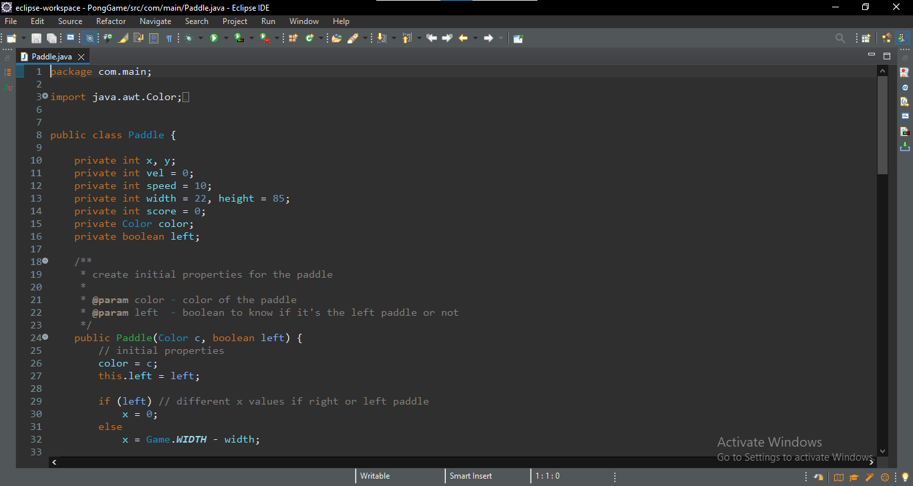

**KeyInput.java** handles the key input in a clever way to avoid the paddles from bugging when the direction changes.

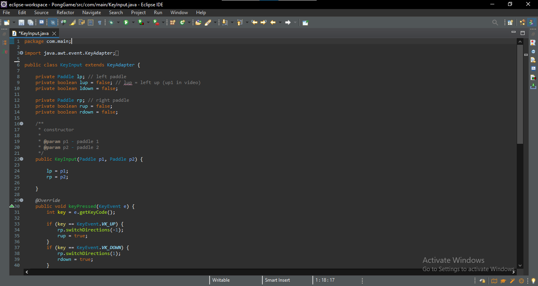

**MainMenu.java** displays a main menu at the start of the game.

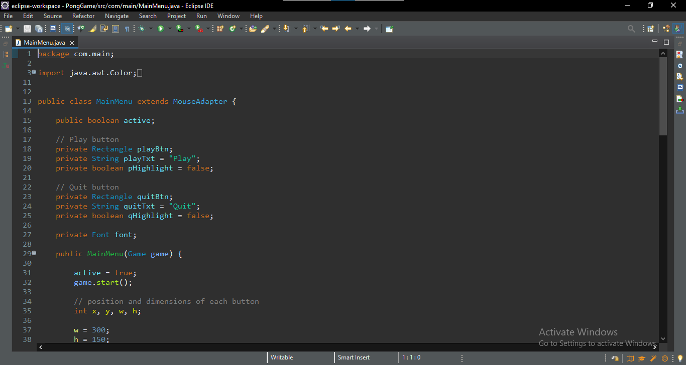

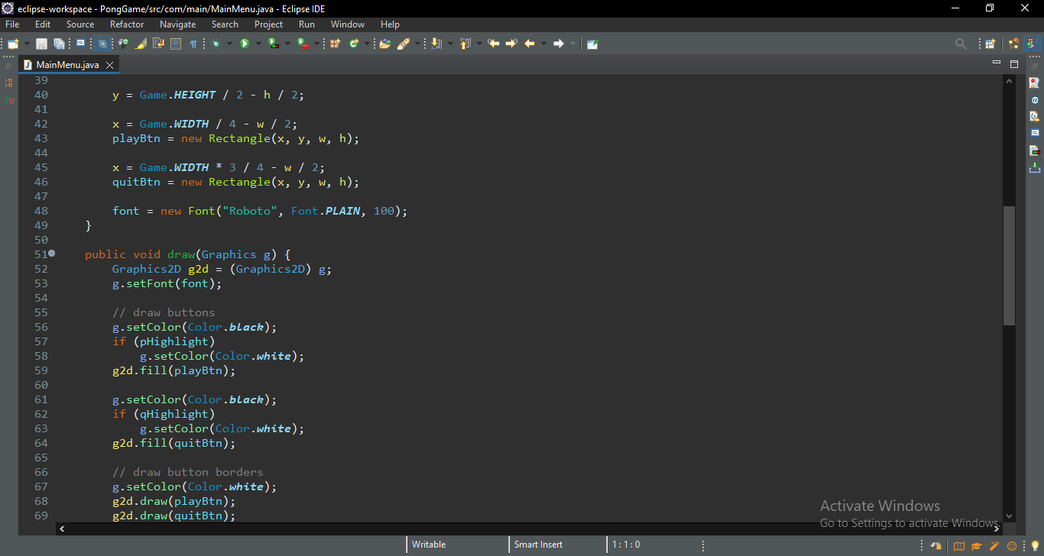

1.1 Displays a main menu at the start of the game.

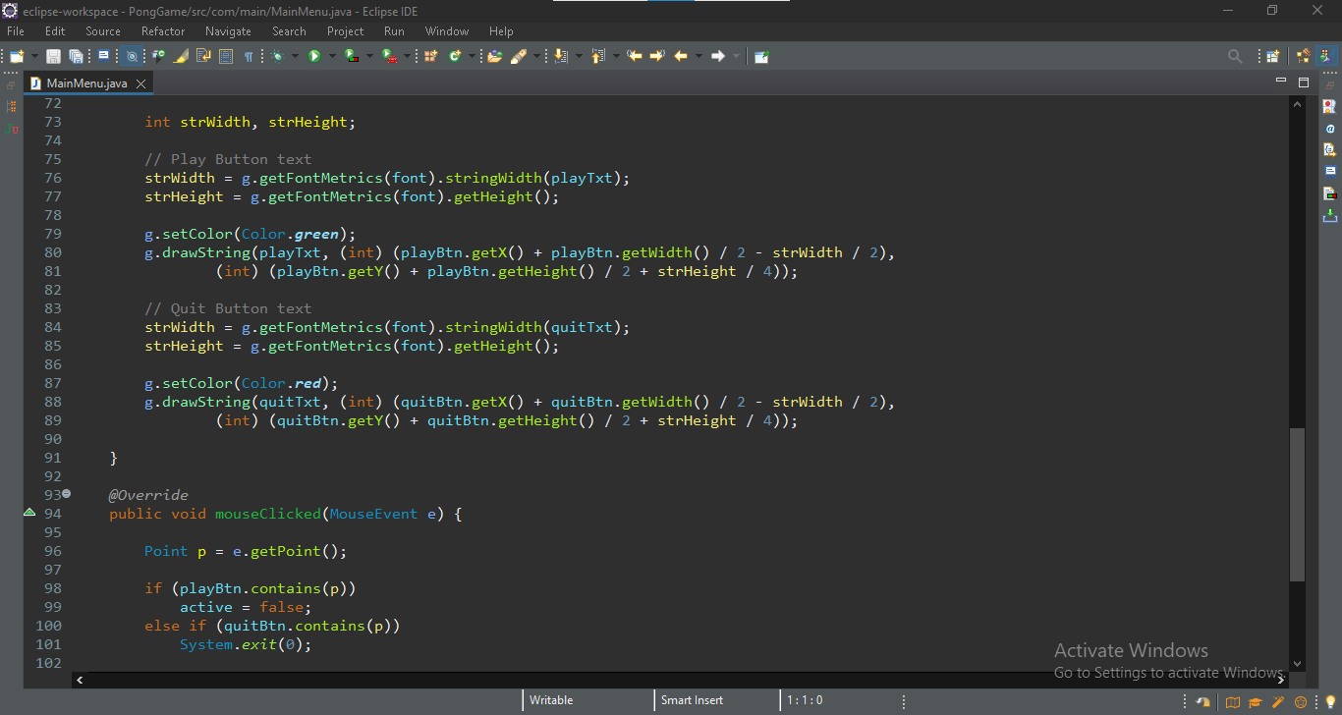

1.2Displays a main menu at the start of the game

**Implementation and Result:**

**Home page to play the game**

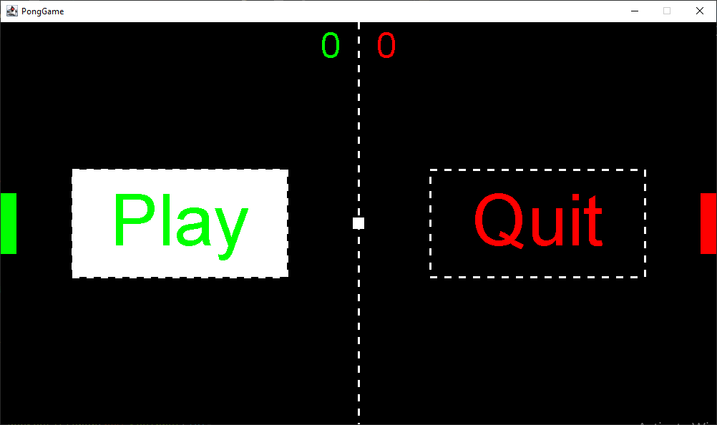

**GAME Playing**

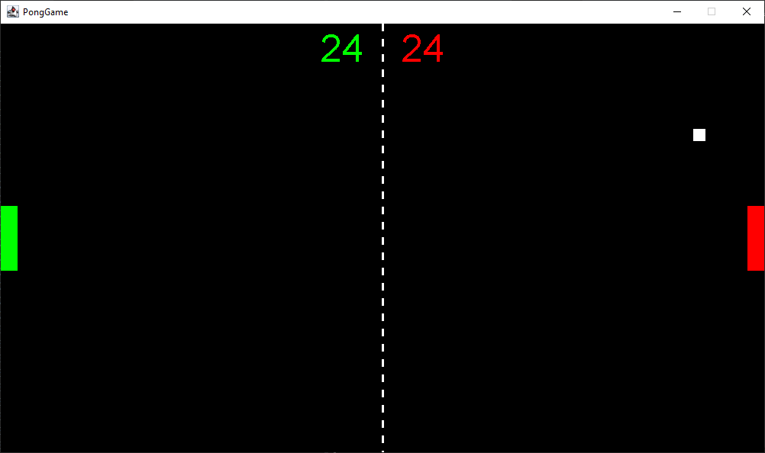

**To Quit the game**

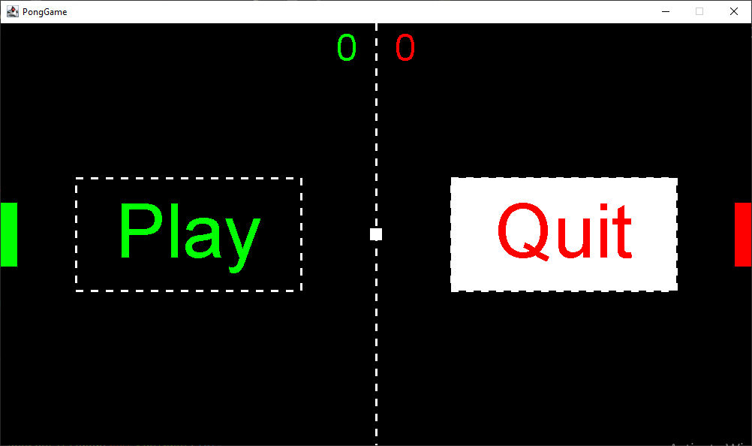

**The final product looks like this:**

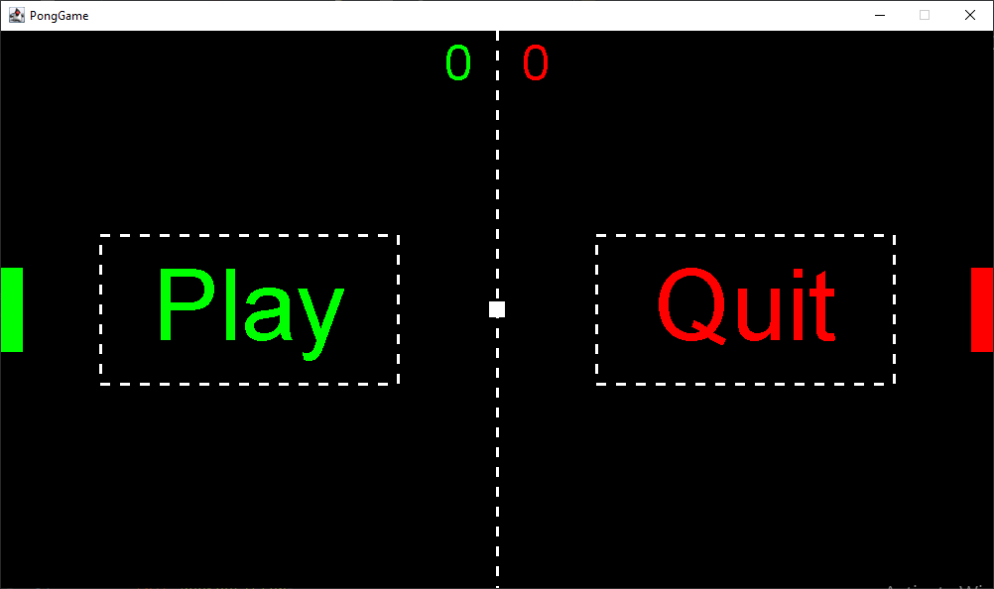

**Conclusion:**

* The project pong game features two paddle controlled by each player and a ball that bounces between those paddle.
* The game has some unique powerups which have different effects on the ball. It makes the game more interesting and fun to play
* The graphics are quite simple as of now with a scoreboard on top of the window.
* The project was made interactive and simple using java swing and AWT.
* though it can be improved in a lot of ways, the outcomes at the moment were quite satisfactory.

**Thank you**